**PARADE USER GUIDE**

**Libraries**



**Version 1.58 Jul 2021**

**Version History**

|  |  |  |  |
| --- | --- | --- | --- |
| **Version** | **Date** | **Author** | **Comments** |
| 1.29 | Sep 2020 | K.Wilson | Original Version |
| 1.30 | Sep 2020 | K.Wilson | Added WITSML export formats |
| 1.58 | Jul 2021 | K.Wilson | Imported new string component data. Modified table and how it used in Strings |

Contents

Introduction 1

String components 1

Pipe grades 2

Materials 2

Hole sizes 3

Import text file formats 3

WITSML export formats 4

# Introduction

Parade contains a number of Library and Template files. Their purpose is to store data that may need to be reused multiple times and by doing so removes the need to re-enter the data each time.

These are accessed using options on the Libraries menu.

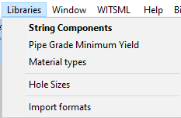

# String components

These items can be copied into an actual string. This option was modified to address the different fields in an external source of component details.

This form defines by the string component types and the components in the library.

For convenience, the components in the grid can be restricted to just the type selected in the Type grid.

In addition additional restrictions can be applied, such as minimum diameter and nominal weight and grade and connection type. By using minimum rather than exact values, the desired records are near the top of the list without the risk of being hidden because of some small rounding error, had exact values been required. Likewise, only the start of a grade or connect type is required and not the full string.

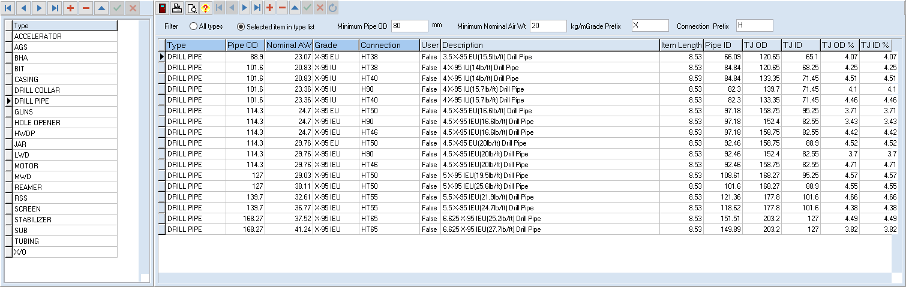

The fields include descriptive ones, such as the description, type, connection, grade make and model and physical properties of the item, such as size composition, quality and strength.

# Pipe grades

This library defines the minimum yield and Young’s modulus values for different grade of different materials. There may be entries for similar codes for the same material eg C-90 and C90

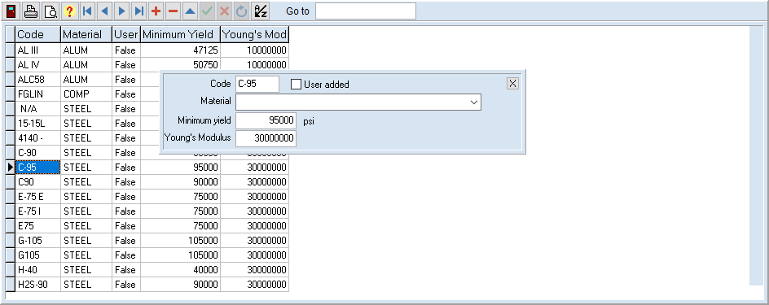

# Materials

This is a library of material types, with their physical properties.

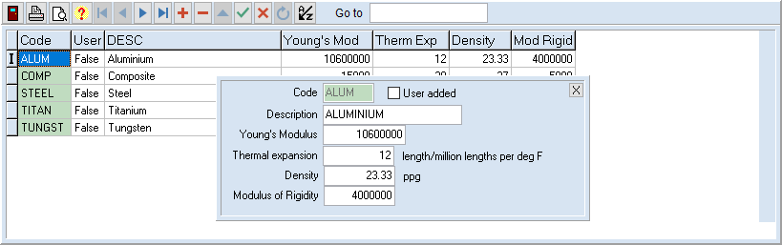

# Hole sizes

The hole size library holds internal diameters of open hole and inside casing for copying to an actual hole profile.

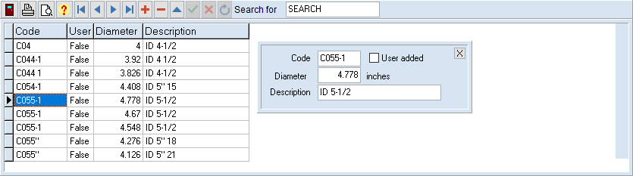

These can be copied in the hole profile screen.

# Import text file formats

A number of table edit forms have an option to import data from a text file.

These require the position of each field in the file to be defined

This template library allows you to save a manually entered format for future use, since often data is imported from the same 3rd party source in the same format.

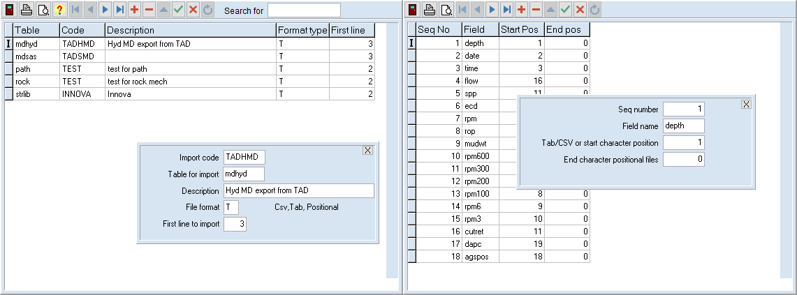

The format header table on the left defines the different formats that have been saved. The field information for the selected format is displayed on the right.

The header table contains an identifying code and description and the table that it applies to.

The file format is also defined as well as the first line to import, to skip over header lines.

The fields are defined by the sequence number and the field name in the table.

For a Tab delimited or CSV file the position is defined by a single number corresponding to the column number, as it would appear if theses files were opened in Excel.

For a positional file, fields are aligned by inserting spaces between the values. In this case, the position is defined by the first and last character of the line to be copied to extract the particular field.

This table is not normally edit directly but saved after entering the values for importing a particular text file.

The format can then be reused when a similar file is to be imported.

Note that the units for the data are not saved and must be selected each time a file is imported. This allows the same format to be used whatever units are used for the data.

# WITSML export formats

The saved export formats can be viewed on the Library menu.

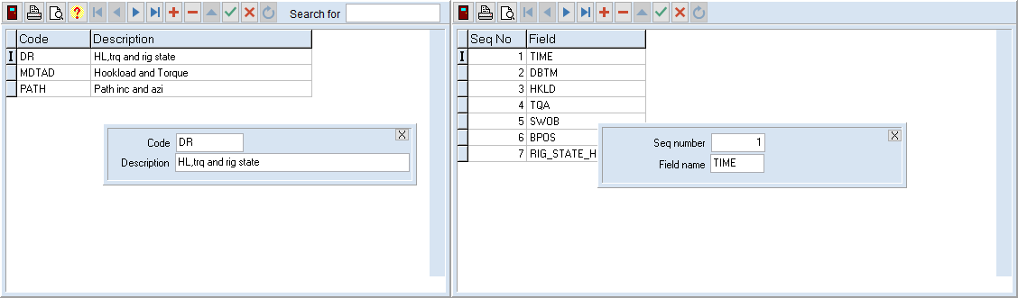

The left grid lists the saved formats.

The right grid lists the field names, in sequence for the selected format.